# Python learning record

All by Wang Yanchen

At the beginning of all program work: “#!/usr/bin/python” to give the source location to the file.

Compile

We have three kinds of file to be created, all is good to run freely, however the difference lie in the speed for computer to finish the task as is programmed.

The orders are as follows:

*Linux system order review:*

*Authority:*

*Order: chmod*

*Format are as follows*

*chmod (range) (+/-/=)(authority)*

*range:*

*u: user, the owner of the file or list*

*g: group, the group of the file or list*

*o: other, all other users except the above*

*a: all, all users,*

*authority:*

*r: read, num4*

*w: write, num2*

*x: execute, num1*

*-: none, num0,*

Practice:

2017-7-8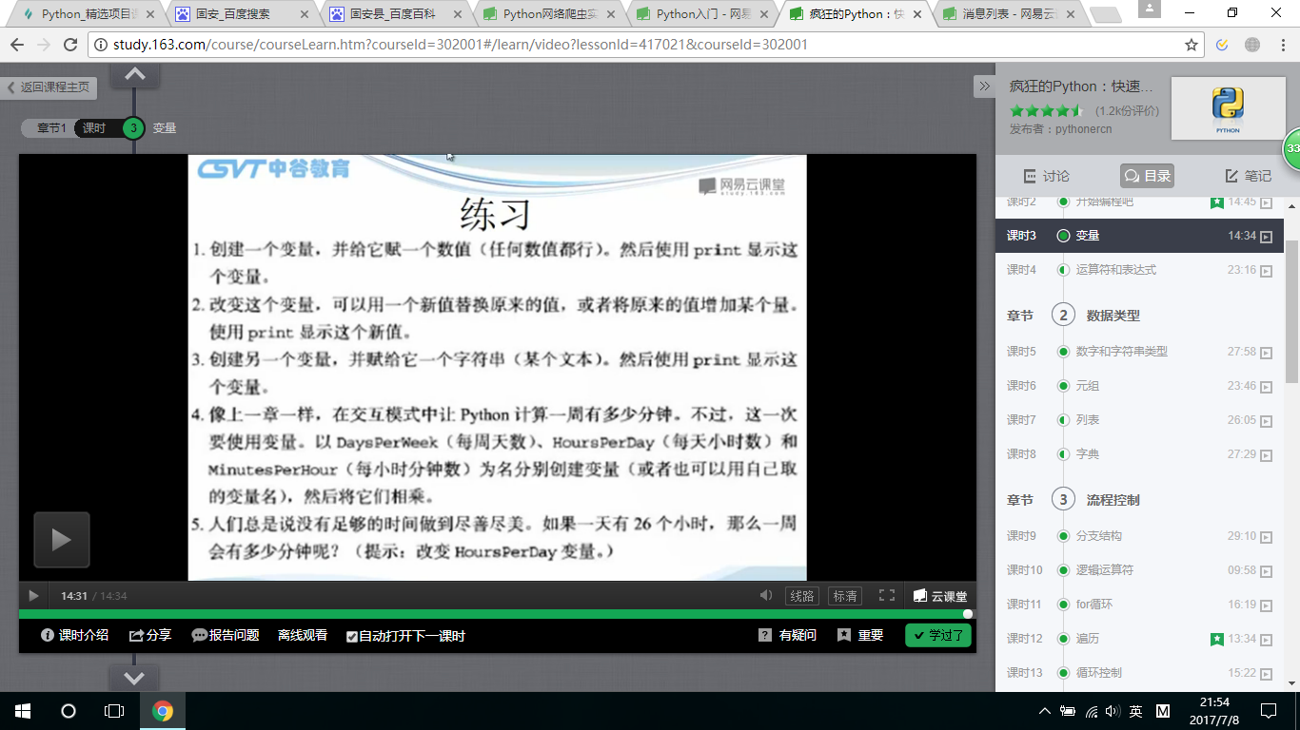 RAM practice